「2011年度美國加州提子乾全港麵飽創意大賽」
為了與業界保持緊密聯繫，幫助學生掌握市場的最新資訊，IVE(黃克競)分校酒店服務及旅遊學系不時舉辦各類型活動，為業界提供一個交流的平台，同時亦為學生提供各種的學習機會。剛完成的活動就有「2011年度美國加州提子乾全港麵飽創意大賽」。是次比賽由加州葡萄乾管理委員會統管，於IVE(黃克競)舉辦，吸引了飽餅業的新貴前來互相切磋。

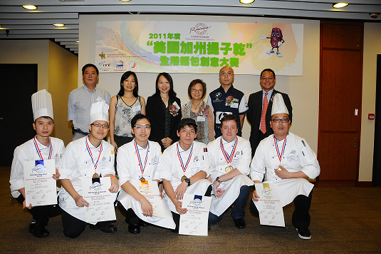
2011年度「美國加州提子乾」全港麵飽創意大賽

Activities Summary for Baking Competition sponsored by the U.S. California Raisin Committee

With the aim to maintain a close communication with the catering trade and to provide to learning platform for our students to gain current industry knowledge and skills, the Hotel, Service & Tourism Studies Discipline organizes regular industry events and competitions to serve as a platform for the trade to exchange ideas and compete under a friendly learning environment. The 2011 Creative Bread Making Competition sponsored by the U.S. California Raisin Committee was held on the 23 June 2011 at IVE (Haking Wong) Campus; the event attracted more than 10 bakers from Hotels and boutique bakery from Hong Kong and the Guangzhou region to compete for several titles.

